24.36: a) 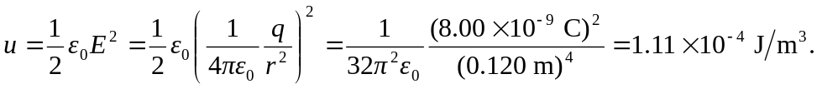
b) If the charge was –8.00 nC, the electric field energy would remain the same since U only depends on the square of E.

